**DATA UNDERSTANDING**

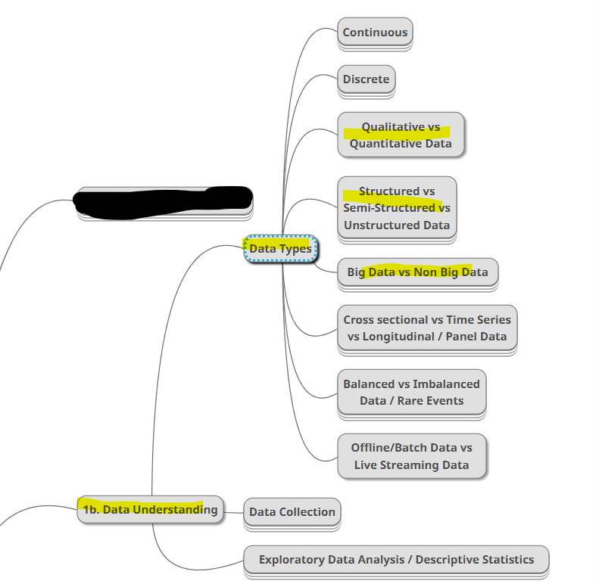

**Quantitative and qualitative data**

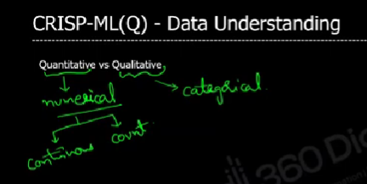

**Example for quantitative and qualitative**

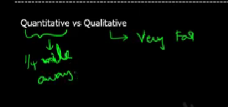

**STRUCTURES UNSTRUCTURED SEMI STRUCTURED DATA**

Unstructured data is a kind of data that can’t be stored in tabular format.

**Ex:**

1. **Video –** Has frame per second that is going to be stored
2. **Image –** Each pixels of image stored

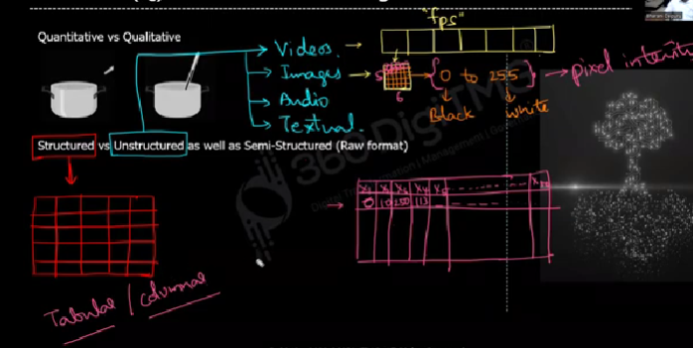

In semi structures data we will convert the unstructured into structure format.

**Ex for semi structured data:**

1. HTML
2. XML
3. Json

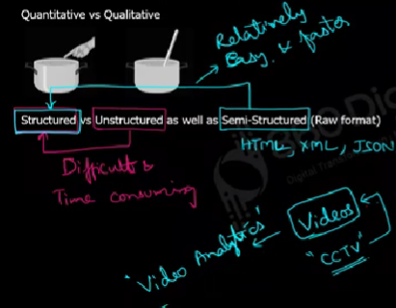

**BIG DATA AND NOT BIG DATA**

A data which has 3Vs are considered as big data

1. Volume – Size of data is very large like TB
2. Velocity – Speed of data generation
3. Variety – Various kind of data
4. Veracity – Uncenterity of data

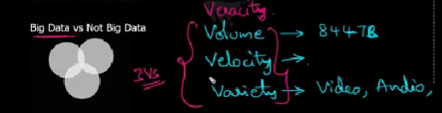

**STORAGE DEVICES OF THESE THREE DATA**

